# HOSPITAL MANAGEMENT SYSTEM

A Project-II Report

Submitted in partial fulfillment of requirement of the Degree of

## BACHELOR OF TECHNOLOGY in COMPUTER SCIENCE & ENGINEERING

BY

**Saloni Agrawal**

**EN18CS301222**

Under the Guidance of **Mr. Asif Lucknowi &**

**Ms. Swati Tahiliani**



**Department of Computer Science & Engineering Faculty of Engineering**

**MEDI-CAPS UNIVERSITY, INDORE- 453331**

## Report Approval

The project work **“Hospital Management System”** is hereby approved as a creditable study of an engineering/computer application subject carried out and presented in a manner satisfactory to warrant its acceptance as prerequisite for the Degree for which it has been submitted.

It is to be understood that by this approval the undersigned do not endorse or approved any statement made, opinion expressed, or conclusion drawn there in; but approve the “Project Report” only for the purpose for which it has been submitted.

Internal Examiner

Name:

Designation:

Affiliation: Medi-Caps University, Indore

External Examiner Name: Designation Affiliation

## Declaration

I/We hereby declare that the project entitled **“Hospital Management System ”** submitted in partial fulfillment for the award of the degree of Bachelor of Technology in ‘Computer Science’ completed under the supervision of **Ms. Swati Tahiliani,** Faculty of Engineering, Medi-Caps University Indore is an authentic work.

Further, I declare that the content of this Project work, in full or in parts, have neither been taken from any other source nor have been submitted to any other Institute or University for the award of any degree or diploma.

**Saloni Agrawal [EN18CS301222]**

## Certificate

I, **Ms. Swati Tahiliani** certify that the project entitled **“**work **“Hospital Management System”** submitted in partial fulfillment for the award of the degree of Bachelor of Technology by **Saloni Agrawal** is the record carried out by her under my guidance and that the work has not formed the basis of award of any other degree elsewhere.

Ms. Swati Tahiliani

Computer Science & Engineering

Medi-Caps University, Indore

Mr. Asif Lucknowi

Project Lead

Technovation Unicorns LLP

Head of the Department

Computer Science & Engineering

Medi-Caps University

Indore

## Acknowledgements

I would like to express my deepest gratitude to Honorable Chancellor, **Shri R C Mittal,** who has provided me with every facility to successfully carry out this project, and my profound indebtedness to **Prof. (Dr.) Dilip K. Patnaik,** Vice Chancellor, Medi-Caps University, whose unfailing support and enthusiasm has always boosted up my morale. I also thank **Dr. Suresh Jain,** Dean, Faculty of Engineering, Medi-Caps University, for giving me a chance to work on this project. I would also like to thank my Head of the Department **Dr. Pramod S. Nair** for his continuous encouragement for betterment of the project.

I express my heartfelt gratitude to my External Guide, **Mr. Asif Lucknowi** , Project Lead, Technovation Unicorns LLP, as well as to my Internal Guide, **Ms. Swati Tahiliani**, Professor, Department of Computer Science Engineering, MU, without whose continuous help and support, this project would never have reached to the completion.

I would also like to thank to my team at Technovation Unicorns who extended their kind support and help towards the completion of this project. It is their help and support, due to which we became able to complete the design and technical report. Without their support this report would not have been possible.

### Saloni Agrawal

B.Tech. IV Year

Department of Computer Science & Engineering Faculty of Engineering

Medi-Caps University, Indore

## Abstract

Many Hospitals currently use a manual system for the management and maintenance of critical information. The current system requires numerous paper forms, with data stores spread throughout the hospital management infrastructure. Often information (on forms) is incomplete, or does not follow management standards. Forms are often lost in transit between departments requiring a comprehensive auditing process to ensure that no vital information is lost. Multiple copies of the same information exist in the hospital and may lead to inconsistencies in data in various data stores.

A significant part of the operation of any hospital involves the acquisition, management and timely retrieval of great volumes of information. This information typically involves; patient personal information and medical history, staff information, room and ward scheduling, staff scheduling, operating theater scheduling and various facilities waiting lists. All of this information must be managed in an efficient and cost wise fashion so that an institution's resources may be effectively utilized HMS will automate the management of the hospital making it more efficient and error free. It aims at standardizing data, consolidating data ensuring data integrity and reducing inconsistencies.

## Keywords:

1. HTML
2. Django
3. SQLite
4. HMS
5. Admin
6. Patient
7. Doctor

## Table of Contents

|  |  |  |
| --- | --- | --- |
|  |  | **Page no.** |
|  | Report Approval | I |
|  | Declaration | ii |
|  | Acknowledgement | iii |
|  | Abstract | iv |
|  | Table of Content | V |
|  | List of Figures | Vi |
| Chapter 1 | Introduction | 11-18 |
|  | 1.1 Introduction |  |
|  | 1.2 Literature Review |  |
|  | 1.3 Objective |  |
|  | 1.4 Scope |  |
|  | 1.5 Problem Statement & Justification |  |
|  | 1.6 Organization |  |
| Chapter 2 | System Requirement Analysis | 19-23 |
|  | 2.1 Information Gathering |  |
|  | 2.2 System Feasibility |  |
|  | 2.2.1 Economical |  |
|  | 2.2.2 Technical |  |
|  | 2.2.3 Behavioral |  |
|  | 2.2.4 Organizational |  |
|  | 2.3 Platform Specification(Devlopment&Deployment) |  |
|  | 2.3.1 Functional Requirement |  |

|  |  |  |
| --- | --- | --- |
|  | 2.3.2 Non-Functional Requirement |  |
|  | 2.3.3 Hardware Requirement |  |
|  | 2.3.4 Software Requirement |  |
| Chapter 3 | System Analysis | 24-28 |
|  | 3.1 Information Flow Representation |  |
|  | 3.1.1 Use case Diagram |  |
|  | 3.1.2 Activity Diagram |  |
|  | 3.1.2.1 Admin activity diagram |  |
|  | 3.1.2.2 Doctor activity diagram |  |
|  | 3.1.2.3 Patient activity diagram |  |
| Chapter 4 | Design | 29-33 |
|  | 4.1 Architectural Design |  |
|  | 4.1.1 Description of architectural design |  |
|  | 4.2 Procedural/Modular Approach |  |
|  | 4.2.1 Modules Used |  |
|  | 4.3 Interface Design |  |
|  | 4.3.1 Human-Machine Interface Design Specification |  |
| Chapter 5 | Testing | 34-42 |
|  | 5.1 Testing Objective |  |
|  | 5.2 Testing Scope |  |
|  | 5.3 Testing Principles |  |
|  | 5.4 Testing Method Used |  |
|  | 5.5 Test Cases |  |
|  | 5.6 Sample Test Data & Results |  |

|  |  |  |
| --- | --- | --- |
| Chapter 6 | Limitations | 43 |
| Chapter 7 | Future Scope | 44 |
| Chapter 8 | Conclusion | 45 |
| Chapter 9 | References | 46 |

**List of Figures**

|  |  |
| --- | --- |
| **Figure no**. | **Figure Name** |
| 3.1.1 | Use case diagram |
| 3.1.2 | Activity Diagram |
| 3.1.2.1 | Admin activity Diagram |
| 3.1.2.2 | Doctor activity Diagram |
| 3.1.2.3 | Patient activity Diagram |
| 4.1 | Architectural Design |
| 5.1 | Test case Table |
| 5.1.1 | Test Case 1 |
| 5.1.2 | Test Case 2 |
| 5.1.3 | Test Case 3 |
| 5.1.4 | Test Case 4 |

* 1. **Introduction**

# CHAPTER-1 INTRODUCTION

With the improvement of the economy and the increase in demand, the hospitals of many hospitals are expanding and expanding, and the application is deepening. Earlier there were only a few systems like [appointment management system](https://vvfit.com/medical-appointment-scheduling-software-system/), medicine time scheduler, etc. Nowadays, the informationization of hospitals has reached a new level. So what exactly is the hospital management system?

Hospital information system, also known as hospital management information system, hospital management system, HIS system, HIS software, hospital management software, refers to the use of computer software and hardware technology, network communication technology and other modern means, the flow of people in the hospital and its various departments, Comprehensive management of logistics and financial resources, collecting, storing, processing, extracting, transmitting, summarizing and processing all kinds of data generated in various stages of medical activities to generate various information, thus providing comprehensive and automated management for the overall operation of the hospital. Information systems may be for various hospital utility services. These may be connected with [medical billing](https://www.pinterest.com/vvfit/medical-billing/) systems for payment of hospital medical bills.

Hospital Management System — The main goal of the medical HMS system is to support the hospital’s administrative management and transaction processing business, reduce the labor intensity of transaction personnel, assist hospital management, assist senior leadership decision-making, and improve the hospital management system, medical HIS (hospital information system) and hospital management activities directly related

information system. The hospital system is aimed at assisting decision-making with the aim of improving the efficiency and level of hospital management and medical work.

### Meaning of Hospital management system

Computer application system for information management and online operation in hospital management and medical activities, the English abbreviation HIS. HIS is an information management system that covers all the processes and services of the hospital. According to the definition given by the academic community Morris F. Collen, it should be: the use of electronic computers and communication equipment to provide patient care information and administration information collection for each department of the hospital (Collect) The ability to store, process, retrieve, and communicate with the capabilities of all users (Authorized Users). The hospital information system consists of a medical information system and a hospital management information system. The modern hospital information system uses computer LAN and workstations, and comprehensively uses cybernetics, information theory, artificial intelligence and system engineering.

### Benefits of Hospital management System or Significance

Hospital management information system is an important tool and means for hospital modern management. It is an important guarantee for hospitals to deepen reform, strengthen management, improve efficiency, and develop harmoniously. It will improve medical quality, promote resource sharing, expand information services, support teaching research, and improve hospitals. Competitiveness and so on are of great significance. Among them, the most important are:

* To optimize the workflow
* To improve the quality of operation
* Shorten the diagnosis and treatment cycle
* To strengthen scientific management
* Saving the cost of diagnosis and treatment
* To change the decision-making method

In short, through the implementation of the hospital management information system, it can effectively promote the hospital information construction, realize the integration of hospital internal management, the efficiency of staff work, the simplification of departmental cooperation, the transparency of departmental revenue, the listing of patient expenses, and the electronicization of medical information. To make the medical service process more efficient, orderly and standardized, bringing a new diagnosis and treatment environment and better medical services to hospitals and patients.

* 1. **Literature Review**

Hospital Management System provides the benefits of streamlined operations, enhanced administration & control, superior patient care, strict cost control and improved profitability.

HMS is powerful, flexible, and easy to use and is designed and developed to deliver real conceivable benefits to hospitals . More importantly it is backed by reliable and dependable support.

This HMS is designed for multispecialty hospitals, to cover a wide range of hospital administration and management processes. It is an integrated end-to-end Hospital Management System that provides relevant information across the hospital to support effective decision making for patient care, hospital administration and critical financial accounting, in a seamless flow.

* 1. **Objective**

The objective of the “[online hospital management system](https://www.cnisolution.net/web-application-development.php)” is to simply track the knowledge of all the staff, patients, treatment provided, and prescription and also to produce periodic reports for analysis. The main goal of the software is to make a decent management tool. The main purpose of this software is to cut back the time taken through the manual system so as to take care of all the records. This project is helpful to cut back the time and quality of maintaining the records. It also helps the incorrect maintenance of patient and patient details. This project has GUI primarily based software system that can facilitate storing, updating, and retrieving the information through varied user- friendly menu-driven modules.

Online [hospital management system website](https://www.cnisolution.net/web-application-development.php) applications will give answers and services for the world health care business. By using these technologies, hospital Management can be improved with economical workflow and communication. Any time anywhere facilities of the net have helped the Medical fields to integrate into one unit. Various Hospitals across the globe are often connected along. They can share data and even services. Details of the Patients, their previous visits, etc. square measure whole not perceptible while not a pc and are obtainable instantly in front of the user.

## 1.4 Scope

Our project aims at Business process automation, i.e. we have tried to computerize various processes of Hospital Management System.

In the computer system the person has to fill the various forms & number of copies of the forms can be easily generated at a time. To assist the staff in capturing the effort spent on their respective working areas. To utilize resources in an efficient manner by increasing their productivity through automation.

The system generates types of information that can be used for various purposes.

1. It satisfies the user requirement.
2. Be easy to understand by the user and operator .
3. Be easy to operate .
4. Have a good user interface and be expandable .

## Problem statement & Justification

**EXISTING SYSTEM**: Hospitals currently use a manual system for the management and maintenance of critical information. The current system requires numerous paper forms, with data stores spread throughout the hospital management infrastructure. Often information is incomplete or does not follow management standards. Forms are often lost in transit between departments requiring a comprehensive auditing process to ensure that no vital information is lost. Multiple copies of the same information exist in the hospital and m ay lead to inconsistencies in data in various data stores

**PROPOSED SYSTEM**: The Hospital Management System is designed for any hospital to replace their existing manual paper based system. The new system is to control the information of patients. Room availability, staff and operating room schedules and patient invoices. These services are to be provided in an efficient, cost effective manner, with the goal of reducing the time and resources currently required for such tasks

## Organization

Medi-Caps is one of the brand names in the arena of technical education and is contributing in making Indore an educational hub. Since its inception in July 2000, the group consistently aims at creating an ideal ambiance for budding technocrats and helping them to grow like true professionals. The main strength of Medi-Caps university is its highly qualified faculty members. We have an optimal blend of academic brilliance and industry exposure, which is supplemented by highly specialized visiting faculty and industry experts, senior professionals from various segments of different industry/ business houses. This has helped in refining the candidature of our graduating students from the Engineering and Management field since the last 21 years.

# CHAPTER-2

**SYSTEM REQUIREMENT ANALYSIS**

### Information Gathering

The information gathering for the working of the proposed model is done through analyzing and studying previous works. It is a way of collecting data by reviewing existing works mainly to gather the background information. Reviewing existing works helps to understand the history, and operation of the program that is being evaluated and the organization in which it operates

.

* 1. **Software Feasibility**

### Economical Feasibility

The proposed model is highly economical since no hardware was required to build this project. This system needs a web server on which the system is being run and other computers via the Internet. This system only requires a laptop and manpower to build the project. Nowadays, the price of the computer has been very low, while the performance has made considerable progress.

### Technical Feasibility

The technology used to implement the proposed model is easily available to all. For development of this project Visual Studio Code is used. Visual Studio Code combines the simplicity of a code editor with what developers need for their core edit-build debug cycle. It provides comprehensive code editing, navigation, and understanding support along with lightweight debugging, a rich extensibility model, and lightweight integration with existing tools. Visual Studio Code is updated monthly with new features and bug fixes. You can download it for Windows, macOS, and Linux on Visual Studio Code's website. To get the latest releases every day, install the Insiders build.

### Behavioral Feasibility

People are inherently resistant to change, and computers have been known to facilitate change. An estimate should be made of how strong a reaction the user is likely to have toward the development of a summarizer system.

### Operational Feasibility

The aspect of study is to check the level of acceptance of the system by the user. This includes the process of training the user to use the system efficiently. The user must not feel threatened by the system, instead must accept it as a necessity. The level of acceptance by the users solely depends on the methods that are employed to educate the user about the system and to make him familiar with it. His level of confidence must be raised so that he is also able to make some constructive criticism, which is welcomed, as he is the final user of the system

## Platform Specification(Development & Deployment)

### Functional Requirements:

“HOSPITAL Management System” has been designed to computerize the following functions that are performed by the system:

1. On-Line Appointments for the Patients
   1. Admission of New Patient
2. Free Medical Advice For the Patients
3. Discharge Detail Functions
   1. Discharge of Patient
   2. Doctor Assigning related to Patient’s Disease
4. Statement of Patient Details
   1. Admitted Patient
   2. Discharged Patient
   3. Doctor Details
5. Doctors available in the Hospital
6. Preventive Health Check-ups
7. Administrator Links (Login Form, add new doctors, List of patients, List of dr., etc.)

### Non-Functional Requirements:

**Performance**: The manual handling of the record is time-consuming and highly prone to error. To improve the performance of the hospital management system, a computerized hospital management system is to be undertaken. The computerized hospital project is fully computerized and user-friendly even if any of the hospital’s members can see the patient’s report and the doctor’s report.

**Efficiency:** The basic need of the project is efficiency. The project should be efficient so that whenever a new patient is admitted, and automatically a bed is assigned and also a doctor is assigned to the patient according to the patient’s disease. And if any patient is getting discharged, the bed assigned to him/her should automatically free in the computer.

**Control**: The complete control of the project is under the hands of an authorized person who has the password to access this project and illegal access is not supposed to deal with. All the control is under the administrator and the other members have the right to just see the records not to change any transaction or entry.

**Security:** Security is the main criteria for the proposed system. Since illegal access may corrupt the database and it will affect not only the hospital but also it also affects the patient’s life. So security has to be given in this project.

### Hardware Requirements:

Personal Computer/ Laptop Internet Connection

### Software Requirements:

Operating System: Windows 10 Editor: VS Code

Front-End Tool: HTML, CSS, JavaScript, Bootstrap Back-End: Python, Django

Database: SQLite

**CODE EDITOR -** Visual Studio Code is a lightweight but powerful source code editor which runs on your desktop and is available for Windows, macOS, and Linux. It comes with built-in support for JavaScript, Typescript, and Node.js and has a rich ecosystem of extensions for other languages and runtimes.

Its features include support for debugging, syntax highlighting, intelligent code completion, snippets, code refactoring, and embedded Git. Users can change

The theme, keyboard shortcuts, preferences, and install extensions that add additional functionality.

### BACK-END:

**Django**: It is a high-level Python web framework that enables the rapid development of secure and maintainable websites. Built by experienced developers, Django takes care of much of the hassle of web development, so you can focus on writing your app without needing to reinvent the wheel. It is free and open-source, has a thriving and active community, great documentation, and many options for free and paid-for support.

Django was initially developed between 2003 and 2005 by a web team that was responsible for creating and maintaining newspaper websites. After creating several sites, the team began to factor out and reuse lots of common code and design patterns. This common code evolved into a generic web development framework, which was open-sourced as the "Django" project in July 2005.

### FRONT END:

**HTML:** Hypertext Mark-up Language is the standard mark-up language for documents designed to be displayed in a web browser. It can be assisted by technologies such as Cascading Style Sheets and scripting languages such as JavaScript.

**CSS:** Cascading Style Sheets is a style sheet language used for describing the presentation of a document written in a mark-up language such as HTML. CSS is a cornerstone technology of the World Wide Web, alongside HTML and JavaScript.

**JavaScript:** JavaScript, often abbreviated as JS, is a programming language that conforms to the ECMAScript specification.

**Bootstrap:** Bootstrap is the most popular HTML, CSS, and JavaScript framework for developing a responsive and mobile-friendly website. It is free to download and use. It is a front-end framework used for easier and faster web development.

### DATABASE:

**SQLITE 3:** It is an in-process library that implements a self-contained, server less, zero- configuration, transactional SQL database engine. The code for SQLite is in the public domain and is thus free for use for any purpose, commercial or private. SQLite is the most widely deployed database in the world with more applications than we can count, including several high-profile projects.

SQLite is an embedded SQL database engine. Unlike most other SQL databases, SQLite does not have a separate server process. SQLite reads and writes directly to ordinary disk files. A complete SQL database with multiple tables, indices, triggers, and views, is contained in a single disk file**.**

The following diagram illustrates the SQLite server-less architecture:

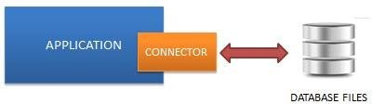

# CHAPTER-3

**SOFTWARE REQUIREMENT & ANALYSIS**

## Information Flow Representation

* + 1. **Use Case Diagram:** Use case diagrams model the functionality of a system using actors and use cases.

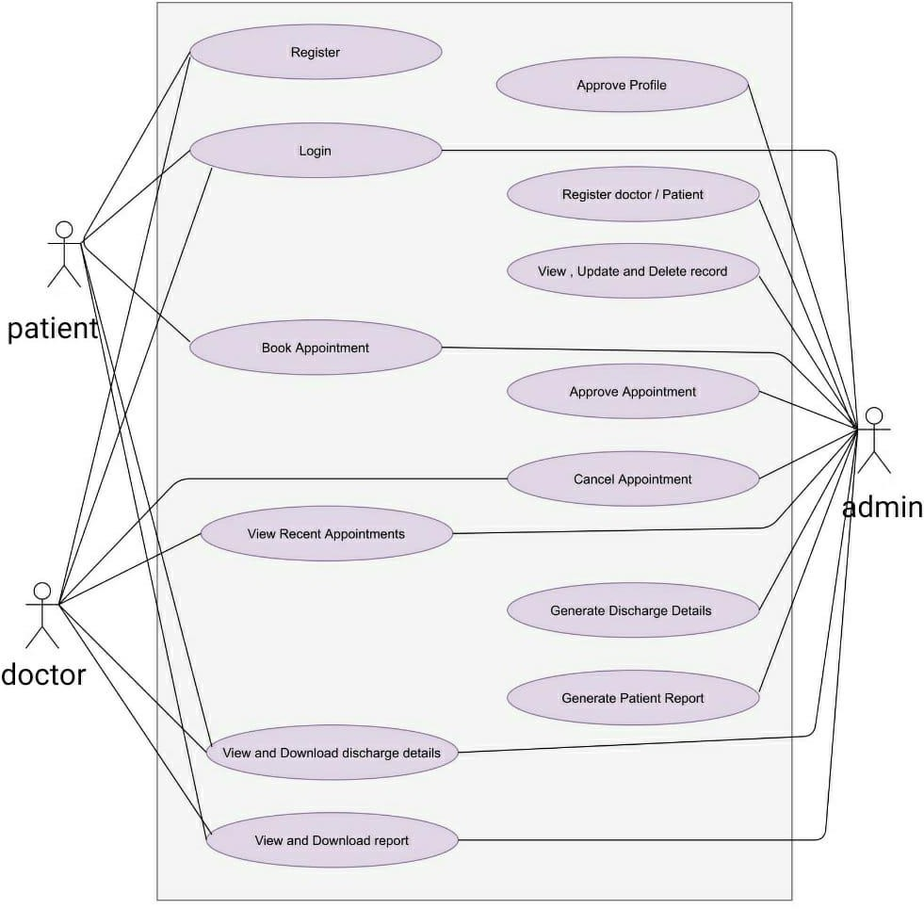

* + 1. **Activity diagram:** An activity diagram portrays the control flow from a start point to a finish point showing the various decision paths that exist while the activity is being executed.

### Admin Activity Diagram:

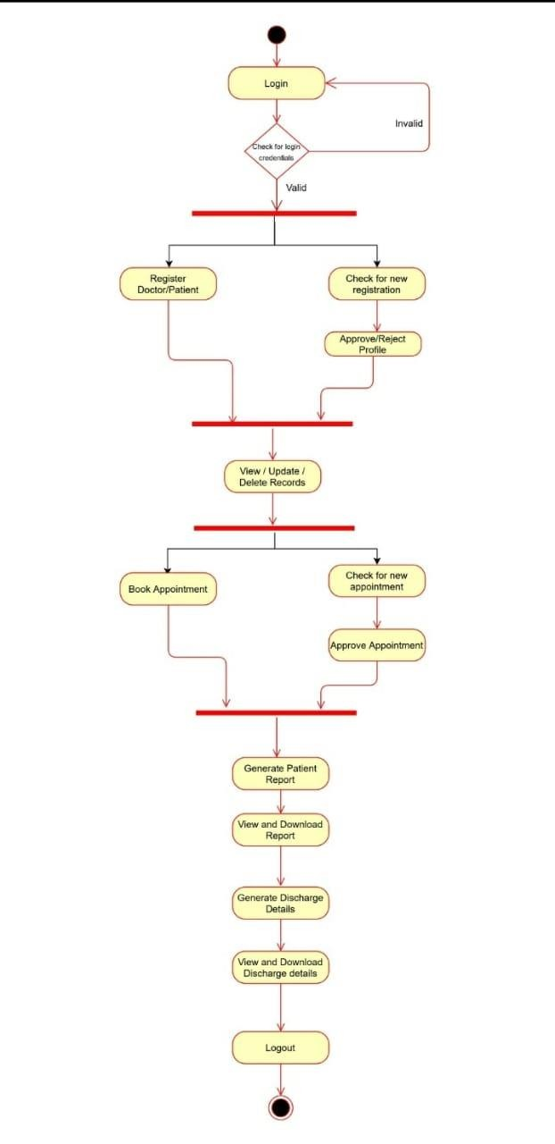

* + - 1. **Patient Activity Diagram:**

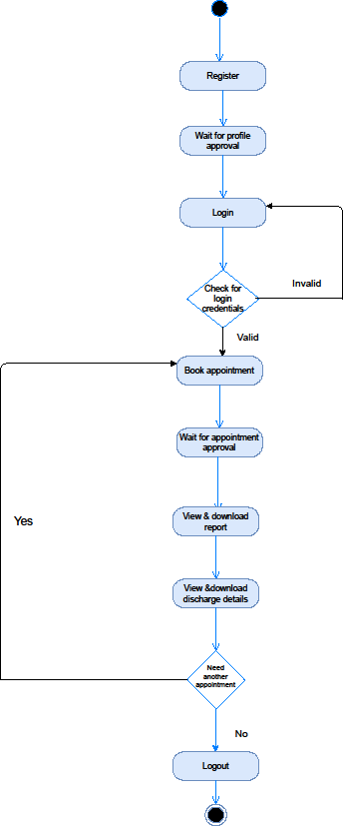

* + - 1. **Doctor Activity Diagram:**

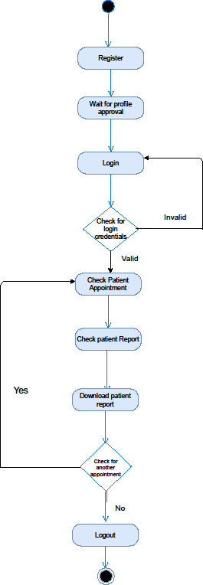

# CHAPTER- 4 DESIGN

## Architectural Design

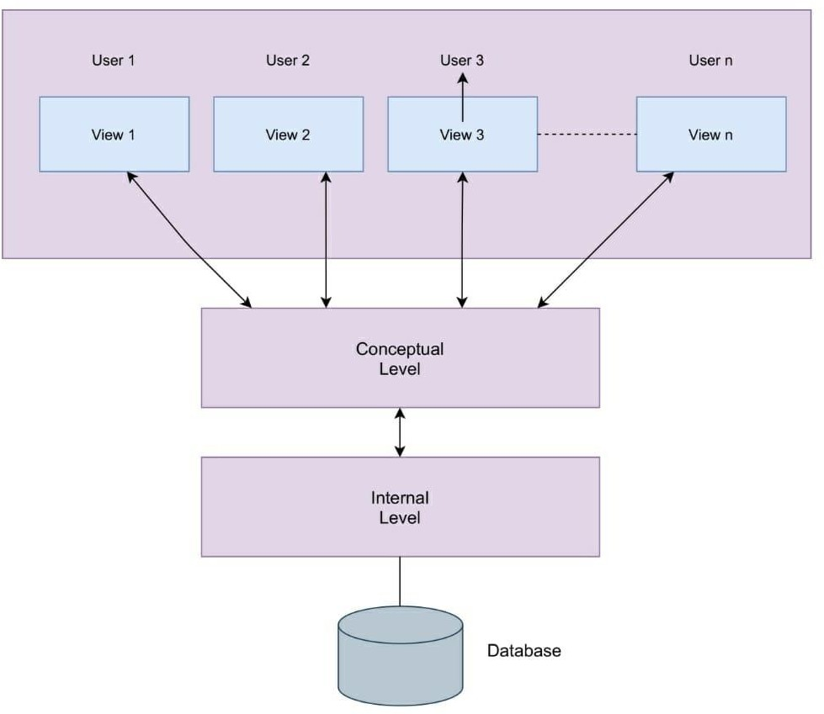

* + 1. **Description of Architectural Diagram :**

The application has been developed on a 3-tier architecture design .

1. Tier one is the user interface layer, which runs on the end-user's computer.
2. Tier two is the data processing layer. This middle tier runs on a server and is often called the application server
3. Tier three is the data storage system, which stores the data required by the middle tier in the database server. This third layer is called the back-end server.

Each layer of the layered architecture pattern has a specific role and responsibility within the application.

## Modular Approach

### Admin

Signup their account. Then Login (No approval Required).

Can register/view/approve/reject/delete doctor (approve those doctor who applied for job in their hospital).

Can admit/view/approve/reject/discharge patient (discharge patient when treatment is done).

Can Generate/Download Invoice pdf (Generate Invoice according to medicine cost, room charge, doctor charge and other charge).

Can view/book/approve Appointment (approve those appointments which is requested by patient).

### Doctor

Apply for job in hospital. Then Login (Approval required by hospital admin, Then only doctor can login).

Can only view their patient details (symptoms, name, mobile ) assigned to that doctor by admin.

Can view their discharged(by admin) patient list. Can view their Appointments, booked by admin.

Can delete their Appointment, when doctor attended their appointment.

### Patient

Create account for admit in hospital. Then Login (Approval required by hospital admin, Then only patient can login).

Can view assigned doctor's details like ( specialization, mobile, address). Can view their booked appointment status (pending/confirmed by admin). Can book appointments.(approval required by admin)

Can view/download Invoice pdf (Only when that patient is discharged by admin)

# CHAPTER -5 TESTING

## Testing Objective

[Software Testing](http://tryqa.com/) has different goals and objectives. The major objectives of Software testing are as follows: [Finding defects](http://tryqa.com/what-is-defect-or-bugs-or-faults-in-software-testing/) which may get created by the programmer while developing software.

Software testing helps in finalizing the software application or product against business and user requirements. It is very important to have good test coverage in order to test the software application completely and make it sure that it’s performing well and as per the specifications. We have tested our android application with various sender mail id’s and different contents for body.

## Testing Scope

Software testing is a matured process of verification or validation of software against the features, requirements or specifications, which are both functional as well as non- functional. It involves creating test plans, test specifications, test code development, execution of tests and checking the documentation. Also, making sure that the product code changes doesn’t cause the regressions, which means failure of earlier working features.

The prototype present in this report has a vast scope for testing the user interface by getting someone with a fresh set of eyes to review the portal.

When working on a project for a while, it’s often difficult to spot typos, spelling mistakes, and other small errors. Whenever possible, some other person who is not directly involved with the project could be asked to review the same.

When added more functionalities we can also test by uploading different types of texts and compare the summaries. We can also give them guidelines about the type of feedback we are looking for in each review cycle.

## Testing Principles:

Software testing is a process of executing a program with the aim of finding the error. To make our software perform well it should be error free. If testing is done successfully it will remove all the errors from the software.

There are seven principles in software testing:

1. Testing shows presence of defects
2. Exhaustive testing is not possible
3. Early testing
4. Defect clustering
5. Pesticide paradox
6. Testing is context dependent
7. Absence of errors fallacy

**Testing shows presence of defects**: The goal of software testing is to make the software fail. Software testing reduces the presence of defects. Software testing talks about the presence of defects and doesn’t talk about the absence of defects. Software testing can ensure that defects are present but it cannot prove that software is defects free. Even multiple testing can never ensure that software is 100% bug-free. Testing can reduce the number of defects but not removes all defects.

**Exhaustive testing is not possible**: It is the process of testing the functionality of a software in all possible inputs (valid or invalid) and pre-conditions is known as exhaustive testing. Exhaustive testing is impossible means the software can never test at every test cases. It can test only some test cases and assume that software is correct and it will produce the correct output in every test cases. If the software will test every test cases then it will take more cost, effort, etc. and which is impractical.

**Early Testing:** To find the defect in the software, early test activity shall be started. The defect detected in early phases of SDLC will very less expensive. For better performance of software, software testing will start at initial phase i.e. testing will perform at the requirement analysis phase.

**Defect clustering:** In a project, a small number of the module can contain most of the defects. Pareto Principle to software testing state that 80% of software defect comes

from 20% of modules.

**Pesticide paradox:** Repeating the same test cases again and again will not find new bugs. So it is necessary to review the test cases and add or update test cases to find new bugs.

**Testing is context dependent:** Testing approach depends on context of software developed. Different types of software need to perform different types of testing. For example, the testing of the e-commerce site is different from the testing of the Android application.

**Absence of errors fallacy:** If a built software is 99% bug-free but it does not follow the user requirement then it is unusable. It is not only necessary that software is 99% bug- free but it also mandatory to fulfil all the customer requirements

## Testing Methods Used:

Functional testing: Functions are tested by feeding them input and examining the output. Functional testing happens in the source code, where the system is tested against functional requirements and specifications according to the user.

Interface Testing: Interface testing ensures that all interactions between the web server and application server interfaces are running smoothly. This includes checking the communication processes as well as making sure that error messages are displayed correctly.

Further things to test are that interruptions by the user as well as by the server are handled correctly.

Compatibility Testing: Ensuring that the application is compatible with all browsers and devices is a key step in web application testing

## 5.5 Test Cases:

|  |  |  |  |
| --- | --- | --- | --- |
| **S no.** | **Input Description** | **Expected Output** | **Pass/Fail** |
| **1.** | Registration & Profile approval | Successfully login on dashboard | **Pass** |
| **2.** | Appointment approval | Successfully appointment is scheduled | **Pass** |
| **3.** | Generate & download report | Successfully generated & downloaded by download button | **Pass** |
| **4.** | Generate & download bill. | Successfully generated & downloaded by download button | **Pass** |

# CHAPTER : 6 LIMITATIONS

Computers are deficient in human intelligence and sometimes fail to understand the language & feelings. So this makes HMS have some limitations which are as follows:

* + - 1. The lack of healthcare professional support, motivation, and more.
      2. In case of a system crash, running operations would seem a difficult task.
      3. Specific care is required to manage the payment gateways and third-party payment apps.
      4. The time required to understand and assign the workflows to the various healthcare professionals is more.
      5. Training for simple computer operations is necessary for the users working on the system.
      6. The size of the database increases day-by-day, increasing the load on the database back up and data maintenance activity.

# CHAPTER-7 FUTURE SCOPE

The proposed system is Hospital Management System. The project is wide in scope

* + - * 1. We can enhance this system by including more facilities like pharmacy system for the stock details of medicines in the pharmacy.
        2. By including payment gateway for more efficient billing processes.
        3. It may try to analyze the user behavior and preferences and accordingly suggest response on user query more suitably to fulfill their requirement.

# CHAPTER-8 CONCLUSION

The project Hospital Management System (HMS) is for computerizing the working in a hospital. It is a great improvement over the manual system. The computerization of the system has speed up the process. In the current system, the front office managing is very slow. The software takes care of all the requirements of an average hospital and is capable to provide easy and effective storage of information related to patients that come up to the hospital. It generates test reports and also provides the facility for searching the details of the patient.

Hospital management system is all about the modernizing a hospital through use of technology. Computers helps in it and take over the manual system for quick and easy functioning. This hospital management system is a quite the reliable and is proven on many stages. All the basic requirements of the hospital are provided in the hospital in order to manage it perfectly and large amount of data can also be stored . It gives many facilities like searching for the detail of patient as well as the creation of test reports. So it’s an important system for modern days.

# CHAPTER-9

**REFERENCES**

https://stackoverflow.com https://en.wikipedia.org/wiki https://docs.djangoproject.com/en/3.2/ <https://www.sqlite.org/docs.html>/ <https://www.w3schools.com/> https://[www.fortishealthcare.com/](http://www.fortishealthcare.com/)